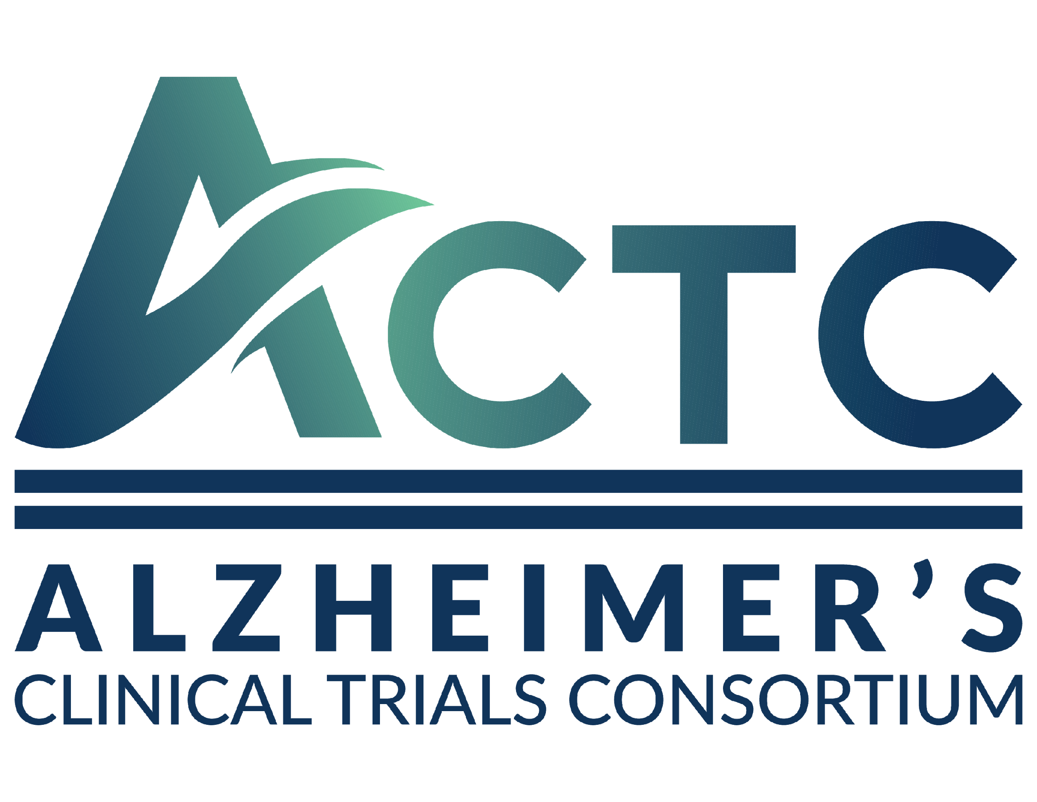

Alzheimer’s Clinical Trials Consortium (ACTC)
Clinical Study Concept Proposal
Title:

Project Lead Investigator(s): | Institution Name:
Email address: | Date:
NIA funding opportunity: PAR-18-513
Key Dates:
LOI:
Application Due:
Can the information provided in this form be circulated within the ACTC program for purposes of determining feasibility?
☐ Yes
☐ No, please provide a brief synopsis of your proposal that can be circulated within ACTC
All proposals will be required to abide by the ACTC Data Sharing Plan. Please confirm that you are in agreement with this requirement by checking the box. ☐

Scientific Proposal (limited to 4 pages total)
- Specific Aims

- Background and Significance

- Preliminary Studies, Suitability and Feasibility
- Briefly describe relevant non-clinical or clinical evidence used to support this trial.
- Describe the fit of the proposal with the strengths of the Consortium

- Research Design and Methods
- Briefly describe the proposed trial design
- Participant Selection criteria: inclusion and exclusion

- Please disclose any financial relationships that are relevant to this proposal or could be affected if this proposal is taken up by the ACTC. ‘Relevant’ describes relationships that involve the intervention being tested (such as a grant to study it, intellectual property or a license), a company that has a role in either the project or the intervention (grants, consulting, speaking or employment), or that would benefit if this proposal is taken up by the ACTC.

  - Company: please described their proposed role (design or execution of the project, translation or dissemination of the results) and PI or Co-PI relationships with the company (such as grantee. consultant, speaker or employment).

  - Relationships that involve the intervention or measures or other technologies in the trial: please describe any licenses or patents.

  - Any other relationships you wish to describe.
  - If you (the applicant) owns intellectual property that is being tested in this study, you may not be able to serve as the Principal Investigator for the ACTC project that uses the property (it is possible, for example, to own a measure used as a secondary endpoint and serve as PI). You are welcomed to contact the ACTC Internal Ethics Committee to discuss your relationship. If you have alternate PIs to suggest, please describe them. The ACTC can also assist in identifying a PI.

- Women and Minority Inclusion Plans: Describe any available data regarding potential intervention effect based on sex/gender and racial/ethnic subpopulations and how such evidence can be accounted for in the study design.

Statistical Considerations:
For ACTC Network funded clinical trials, there are two general approaches that can be taken with respect to the statistical design and analysis activities:
- For many funded trials, the ACTC Biostatistics Unit performs all statistical design and analysis functions.
- In other situations, if a Protocol Project Director has previously worked with an external biostatistician, they may be allowed to join the project, under the following conditions:
- The external biostatistician will work collaboratively with the ACTC Biostatistics Unit.
- The ACTC Biostatistics Unit statisticians will serve as the unblinded statisticians for the trial.
- The external biostatistician will be blinded to safety data and interim analysis results during the course of the trial.
- The external biostatistician may participate in the development of the Statistical Analysis Plan, in collaboration with the Biostatistics Unit biostatisticians.
- The external biostatistician may collaborate with the ACTC biostatisticians in the final study analysis (if agreed upon by NIA, and the ACTC PI’s).

Do you plan to request the use of an external statistician for this protocol?
☐ Yes: Please provide the name of the external statistician, contact information, and a rationale for the need to involve the external statistician.
☐ No

If this proposal moves on to the Project Development Committee (PDC), the ACTC Biostatistics Unit will collaborate with the investigators to define the sample size and complete the rest of the statistical considerations section.

**ACTC would like to acknowledge that this form was adapted from the NeuroNEXT study concept synopsis document.

