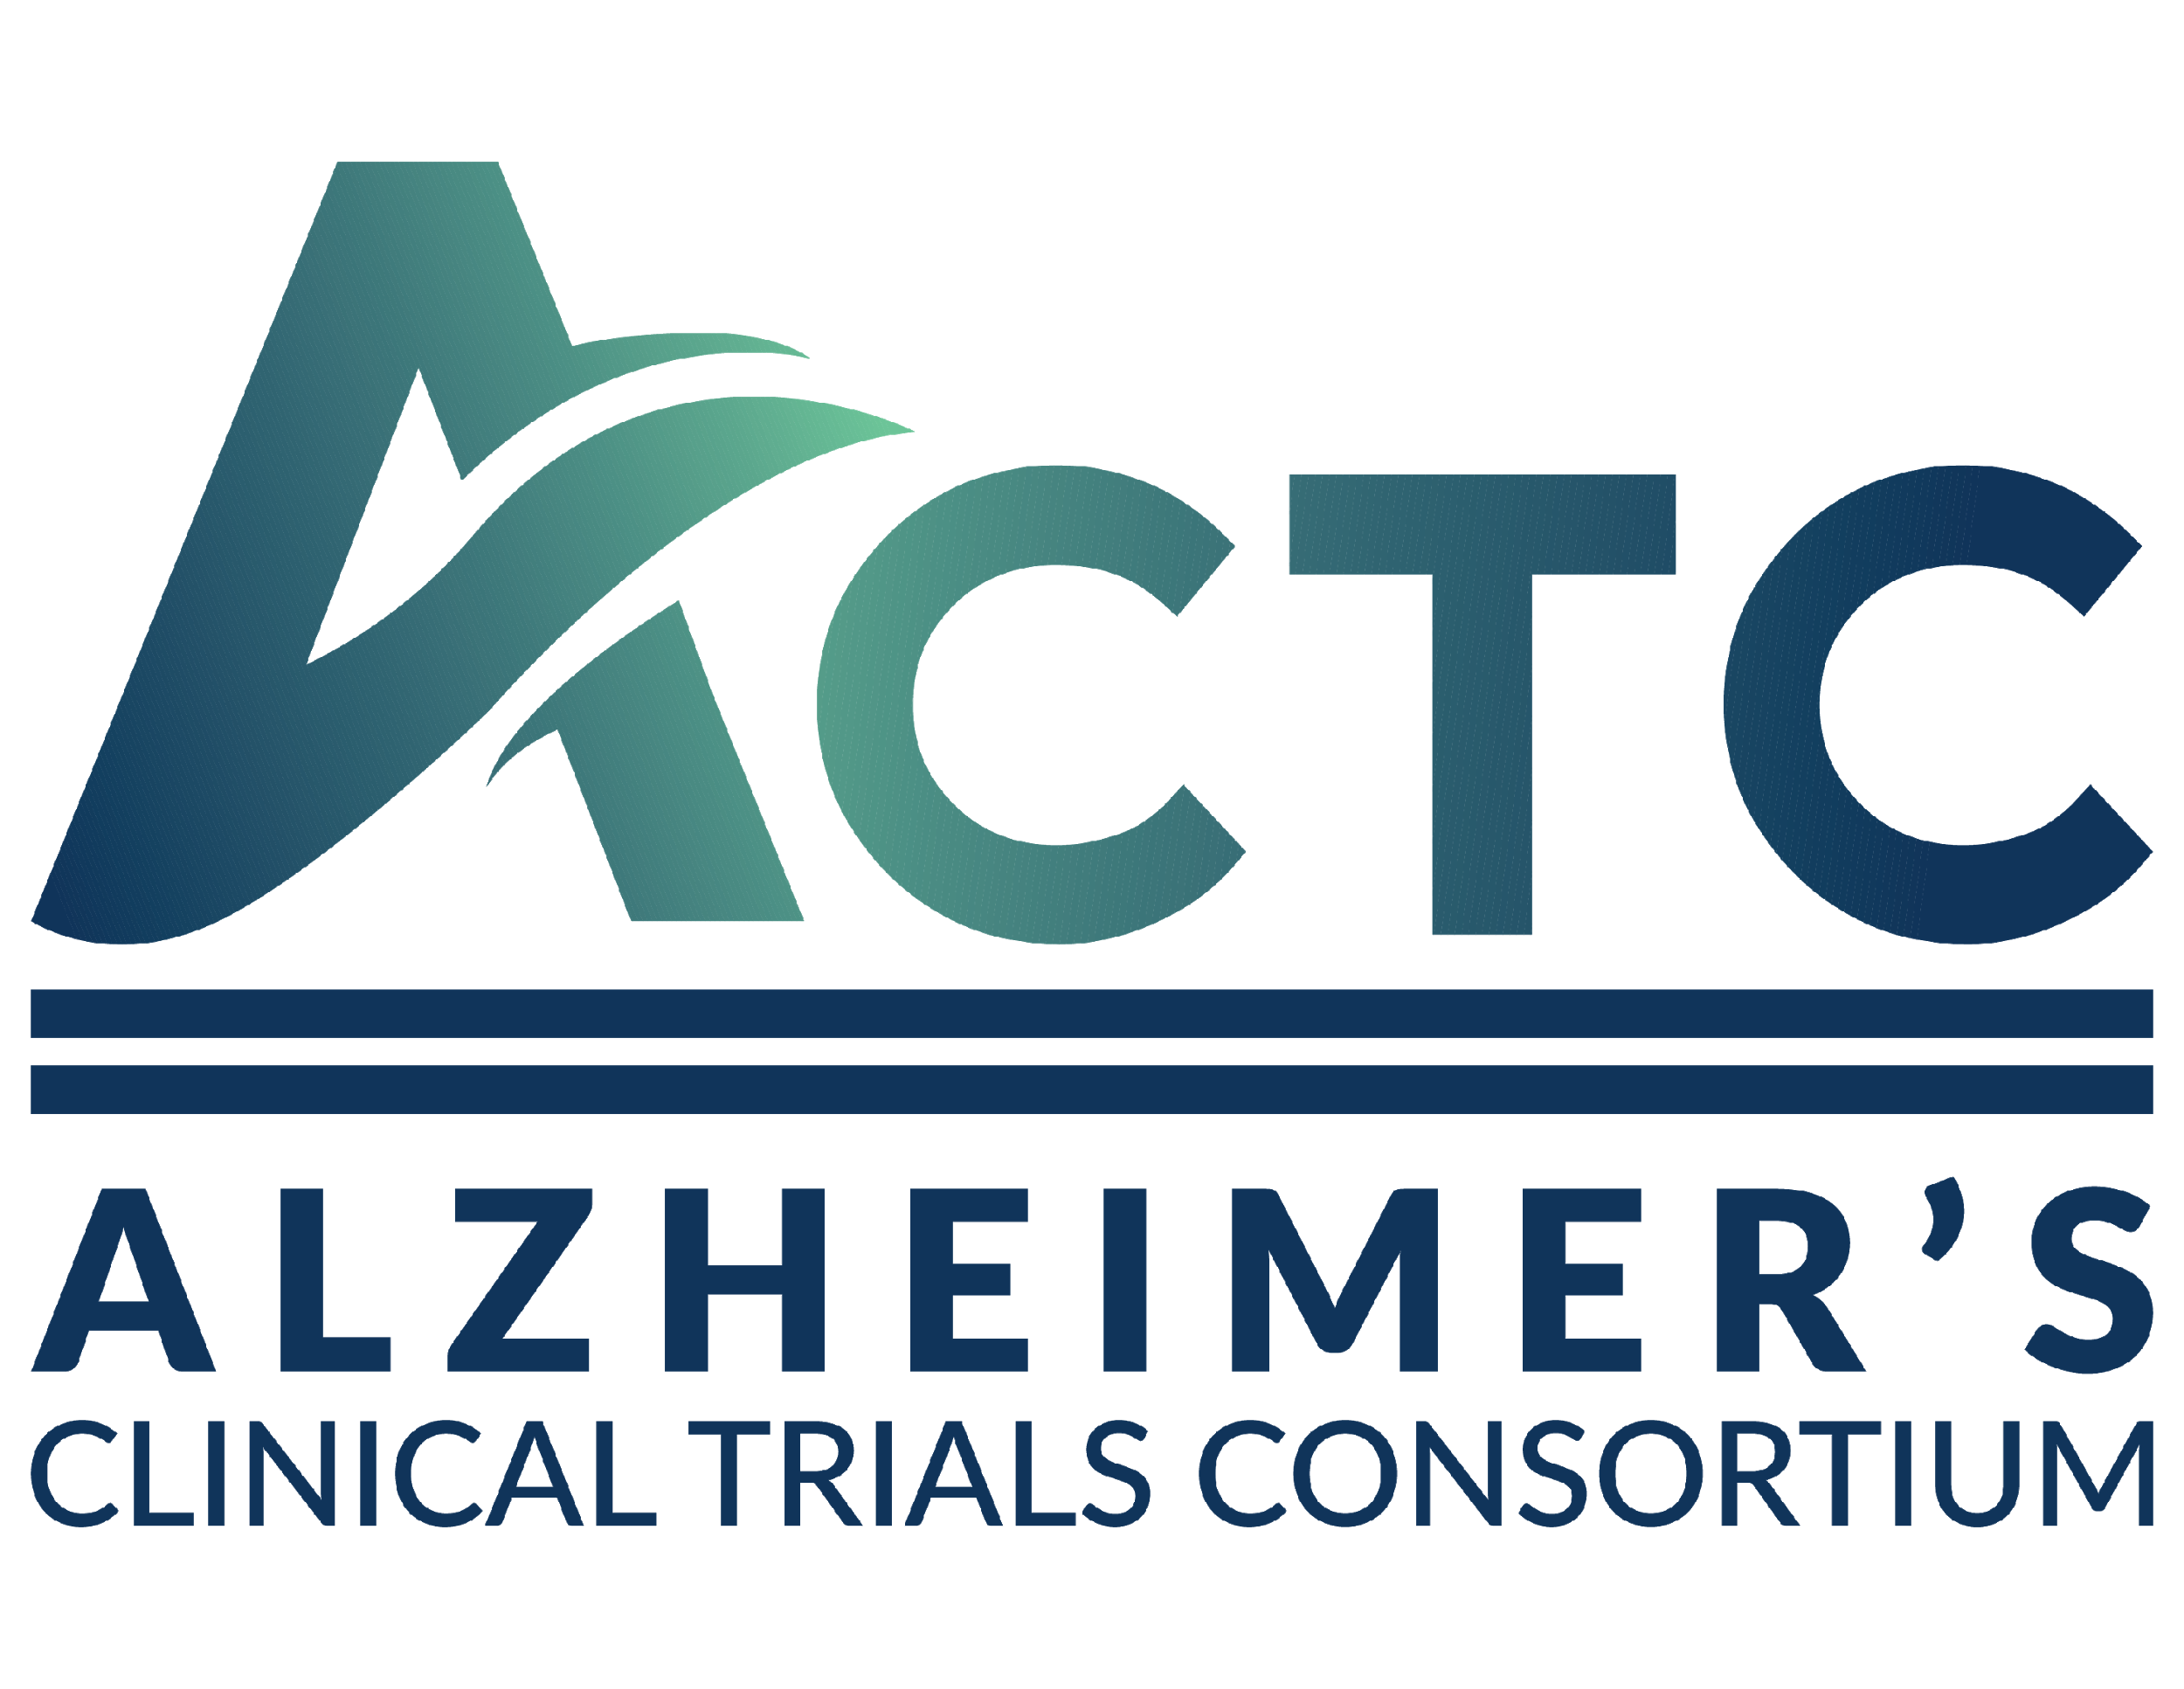

**Alzheimer’s Clinical Trials Consortium (ACTC)**

**Protocol Synopsis**

|  |  |
| --- | --- |
| Study Title |  |
| Principal Investigators |  |
| Study Design |  |
| Study Sponsor |  |
| Objectives |  |
| Population |  |
| Study Participation Duration |  |
| Phase |  |
| Number of Sites |  |
| Description of  Intervention |  |
| Estimated Time to Complete Enrollment |  |
| Key Eligibility Criteria |  |
| Primary Outcome Measure |  |
| Secondary Outcome Measures |  |